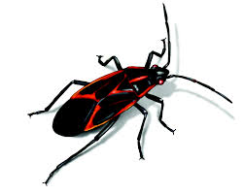
Informative Bug Booklet

You are a master entomologist (N-toe-molo-just), a person who studies bugs, and have been asked by the U.A.E. Bug Society to publish a book on your favorite bug!
You have to choose ONE bug to study and find out all kinds of information about! Your book will have a table of contents to show which pages you can find out information on:
- What your bug looks like
- What your bug eats
- Where your bug lives
- Who your bug lives with (animals and humans)
- How your bug affects the world
- Special adaptations
- Interesting facts
Your book must have an illustrated cover that is FULL of colour. Your book must include all of the categories.

Some class time will be given for research.

This booklet is due on June 3rd, 2016.

