Geometry Review
Complete the chart below.
Shape | Name | Edges (straight) | Faces  (flat) | Vertices  (points) | Slides  (yes/no) | Rolls  (yes/no)
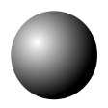
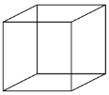
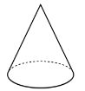
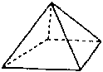
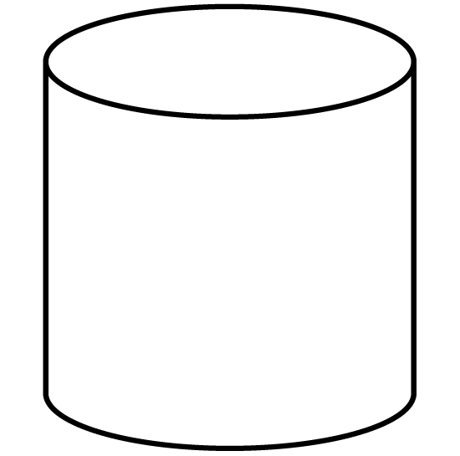

Circle two of the shapes above. How are they alike and how are they different?
They are alike because ________________________________________________
___________________________________________________________________
They are different because _____________________________________________
___________________________________________________________________
Find some objects in your house that are 3D shapes. List the objects and their shapes.
___________________________________________________________________
___________________________________________________________________
___________________________________________________________________
___________________________________________________________________

